CHAPTER 1
INTRODUCTION
1.1 DOMAIN INTRODUCTION
Agriculture is one of the important sectors in the world. I have seen how traditional farming methods rely mainly on farmers experience and manual observation. These methods can lead to problems such as water wastage, crop diseases, poor soil management and reduced crop production. Smart Agriculture is a farming approach that uses technologies such as the Internet of Things (IoT) Artificial Intelligence, Machine Learning, Cloud Computing and Digital Twin Technology to improve agricultural activities. I feel that Smart Agriculture brings hope to farmers.
In this domain IoT sensors are used to collect real-time information about soil moisture, temperature, humidity and environmental conditions. The collected data is sent to a platform for storage, monitoring and analysis. I can see how Smart Agriculture helps farmers stay informed. Artificial Intelligence and Machine Learning help analyse the collected data and provide suggestions for irrigation, crop monitoring and farm management. I think that Artificial Intelligence can save time for farmers.
Digital Twin Technology creates a representation of a real farm. Digital Twin Technology uses real-time sensor data to monitor farm conditions understand changes, in the environment and support decision-making. I imagine that Digital Twin Technology can make farming safer.The main aim of Smart Agriculture is to reduce work save water improve crop productivity reduce farming costs and support sustainable agriculture. I believe that Smart Agriculture will help generations.
The proposed project, "TWIN CLIMATE FARMING – SMART AGRICULTURE SYSTEM " combines these technologies to develop a farming system that helps farmers monitor and manage their farms efficiently. I am excited to see how TWIN CLIMATE FARMING – SMART AGRICULTURE SYSTEM will grow.
CHAPTER 2
LITERATURE SURVEY
2.1 TECHNOLOGY
Literature survey is the most important step in software development process. Before developing the tool it is necessary to determine the time factor, economy and company strength. Once these things are satisfied, then the next step is to determine which operating system and language can be used for developing the tool. Once the programmers start building the tool the programmers need lot of external support.
This support can be obtained from senior programmers, from books or from websites. Before building the system the above consideration are taken into account for developing the proposed system. We have to analysis the Cloud Computing Outline Survey:
Cloud computing providing unlimited infrastructure to store and execute customer data and program. As customers you do not need to own the infrastructure, they are merely accessing or renting; they can forego capital expenditure and consume resources as a service, paying instead for what they use.
Instead of running programs and data on an individual desktop computer, everything is hosted in the “cloud”—a nebulous assemblage of computers and servers accessed via the Internet. Cloud computing lets you access all your applications and documents from anywhere in the world, freeing you from the confines of the desktop and making it easier for group members in different locations to collaborate.
In short, cloud computing enables a shift from the computer to the user, from applications to tasks, and from isolated data to data that can be accessed from anywhere and shared with anyone. The user no longer has to take on the task of data management; he doesn’t even have to remember where the data is.

Benefits of Cloud Computing:
- Minimized Capital expenditure
- Location and Device independence
- Utilization and efficiency improvement
- Very high Scalability
- High Computing power
How secure is encryption Scheme:
- Is it possible for all of my data to be fully encrypted?
- What algorithms are used?
- Who holds, maintains and issues the keys?
- Encryption accidents can make data totally unusable.
- Encryption can complicate availability Solution

2.2 EXISTING SYSTEM
As data generation is far outpacing data storage it proves costly for small firms to frequently update their hardware whenever additional data is created. Also maintaining the storages can be a difficult task. It transmitting the file across the network to the client can consume heavy bandwidths. The problem is further complicated by the fact that the owner of the data may be a small device, like a PDA (personal digital assist) or a mobile phone, which have limited CPU power, battery power and communication bandwidth.
Disadvantages:
- The main drawback of this scheme is the high resource costs it requires for the implementation.
- Also computing hash value for even a moderately large data file can be computationally burdensome for some clients (PDAs, mobile phones, etc).
- Data encryption is large so the disadvantage is small users with limited computational power (PDAs, mobile phones etc.).

2.3 PROPOSED SYSTEM
One of the important concerns that need to be addressed is to assure the customer of the integrity i.e. correctness of his data in the cloud. As the data is physically not accessible to the user the cloud should provide a way for the user to check if the integrity of his data is maintained or is compromised.
In this paper we provide a scheme which gives a proof of data integrity in the cloud which the customer can employ to check the correctness of his data in the cloud. This proof can be agreed upon by both the cloud and the customer and can be incorporated in the Service level agreement (SLA). It is important to note that our proof of data integrity protocol just checks the integrity of data i.e. if the data has been illegally modified or deleted.
Advantages:
- Avoiding local storage of data, it is important to note that our proof of data integrity protocol.
- By reducing the costs of storage, maintenance and personnel.
- It reduces the chance of losing data by hardware failures.
- Not cheating the owner.

2.4.5 ASP or ACTIVE SERVER PAGES
Active Server Pages (ASP), also known as Classic ASP, was introduced in 1998 as Microsoft's first server side scripting engine. ASP is a technology that enables scripts in web pages to be executed by an Internet server. ASP pages have the file extension .asp, and are normally written in VBScript. ASP.NET is a development framework for building web pages and web sites with HTML, CSS, JavaScript and server scripting.
When a browser requests an ASP file, the ASP.NET engine reads the file, compiles and executes the scripts in the file, and returns the result to the browser as plain HTML. ASP.NET supports three different development models:
Web Pages, MVC (Model View Controller), and Web Forms:

Web Pages  Single Pages Model |  | MVC  Model View Controller |  | Web Forms  Event Driven Model
1. Simplest ASP.NET model.  2. Similar to PHP and classic ASP.  3. Built-in templates and helpers for database, video, graphics, social media and more. |  | 1. MVC separates web applications into 3 different components.  2. Models for data  Views for display  Controllers for input |  | 1.Traditional ASP.NET event driven development model.  2. Web pages with added server controls, server events, and server code.
Fig 2.1 Development Models for ASP.NET

Fig 2.2 Development Models for ASP.NET

Fig 2.3 Development Models for ASP.NET

CHAPTER 3
ANALYSIS OF REVIEWED PAPERS
Table 3.1: Related Reviewed Papers Analysis
Sl. No | Title of the Journal | Authors | Publisher | Summary | Drawbacks
1. | Experiencing 3D Interactions in Virtual Reality and Augmented Reality | Jean-Bernard Martens Wen Qi Dima Aliakseyeu | Eindhoven University of Technology | Paper mentions a The Visual  Interaction Platform (AR environment) | Technology has no Object Detection methods
2. | Introduction to Augmented Reality | R. Silva, J. C. Oliveira, G. A. Giraldi | Jan 2003 National Laboratory for Scientific Computation | Paper mentions a technology scene Generator, Tracking System | Technology cannot get input from screen

CHAPTER 4
Requirement analysis
  - FUNCTIONAL REQUIREMENTS
In software engineering, a functional requirement defines a function of a software system or its component. A function is described as a set of inputs, the behavior, and outputs. Functional requirements may be calculations, technical details, data manipulation and processing and other specific functionality that define what a system is supposed to accomplish. Behavioral requirements describing all the cases where the system uses the functional requirements are captured in use cases.
Here, the system has to perform the following tasks:
- Take userid and password along with secret key, match it with corresponding database entries. If a match is found then continue else raise an error message.
- Encrypt the file to form a new encrypted file by using an encryption algorithm.
- Must be able to retrieve the original file from the encrypted file using the corresponding decryption algorithm.
Table 4.1: Various widgets available in Tkinter
WIDGETS | DESCRIPTION
Label | This widget is used to display text or image on the window/frame
Button | This widget is used to add buttons to the user interface
Canvas | This widget allows one to draw pictures and different types of layouts like texts, graphics etc.
Entry | This widget is used to take as input, a single line text entry from user
Frame | This widget is used as box or container. It holds and organizes the widgets in an orderly fashion
SpinBox | This widget allows users to select from a given number of values

4.2 NON-FUNCTIONAL REQUIREMENTS
In systems engineering and requirements engineering, a non-functional requirement is a requirement that specifies criteria that can be used to judge the operation of a system, rather than specific behaviors. This should be contrasted with functional requirements that define specific behavior or functions. The plan for implementing functional requirements is detailed in the system design.

4.2.1 ACCESSIBILITY
Accessibility is a general term used to describe the degree to which a product, device, service, or environment is accessible by as many people as possible.
4.2.2 MAINTAINABILITY
In software engineering, maintainability is the ease with which a software product can be modified in order to:
- Correct defects
- Meet new requirements
New functionalities can be added in the project based on the user requirements just by adding the appropriate files to existing project using ASP.net and C# programming languages.
Since the programming is very simple, it is easier to find and correct the defects and to make the changes in the project.

4.2.3 SCALABILITY
System is capable of handling increase total throughput under an increased load when resources (typically hardware) are added.
System can work normally under situations such as low bandwidth and large number of users.
4.2.4 PORTABILITY
Portability is one of the key concepts of high-level programming. Portability is the software code base feature to be able to reuse the existing code instead of creating new code when moving software from an environment to another.
Project can be executed under different operation conditions provided it meet its minimum configurations. Only system files and dependant assemblies would have to be configured in such case.
4.3 HARDWARE REQUIREMENTS
- Processor : Any Processor above 500 MHz
- RAM : 512Mb
- Hard Disk : 10 GB
- Input device : Standard Keyboard and Mouse
- Output device : VGA and High resolution Monitor

4.4 SOFTWARE REQUIREMENTS
- Operating system : Windows XP
- Front End : ASP.Net 2.0
- IDE : Visual Studio 2008
- Data Base : SQL Server Management Studio 2005
- Server : Internet Information Services
- Database Connectivity : ODBC Sources (with SQL Server)

CHAPTER 5
SYSTEM DESIGN
5.1 DESIGN GOALS
To enable secure outsourcing of file under the aforementioned model, our mechanism design should achieve the following security and performance guarantees:

5.1.1 INPUT/OUTPUT PRIVACY
No sensitive information from the customer’s private data can be derived by the cloud server during performing the encryption and transfer.

5.1.2 EFFICIENCY
The local computations done by customer should be substantially less than. The computation burden on the cloud server should be within the comparable time complexity of existing practical algorithms for encryption and decryption of files.

5.2 SYSTEM ARCHITECTURE
The Meta data sent by the cloud is decrypted and the corresponding bit in this decrypted Meta data is compared with the bit that is sent by the cloud. Any mismatch between the two would mean a loss of the integrity of the client’s data at the cloud storage.
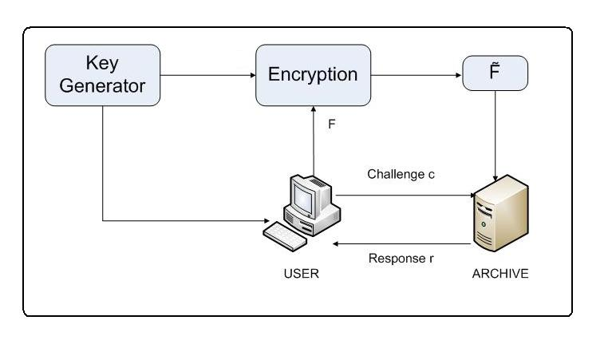
Fig 5.1 System Architecture
5.3 DATA FLOW DIAGRAM
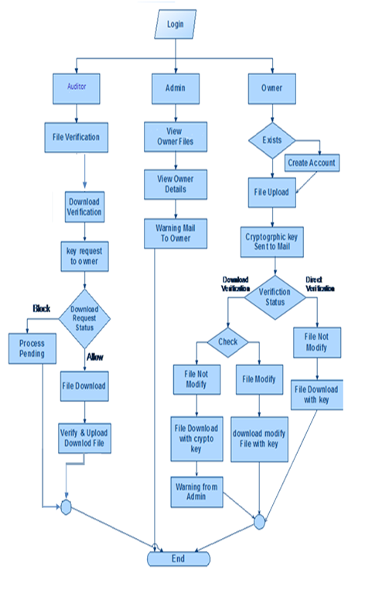
Fig 5.2: Data Flow diagram

5.4 SEQUENCE DIAGRAM
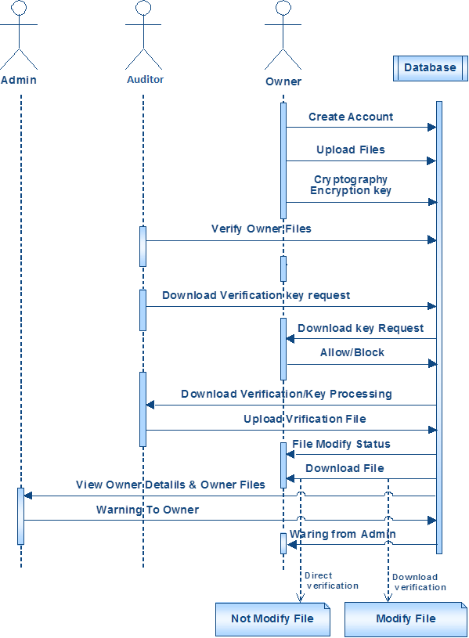
Fig 5.3: Sequence diagram
CHAPTER 6
IMPLEMENTATION

CHAPTER 7
OUTPUTS

CHAPTER 8
TESTING

CHAPTER 9
CONCLUSION AND FUTURE SCOPE

BIBLIOGRAPHY
[1] A. Gersho and R. M. Gray, Vector quantization and signal compression. Massachusetts, USA: Springer Science & Business Media, 1992.
[2] R. M. Gray, “Vector quantization,” IEEE ASSP Magazine, pp. 4–29, April 1984.
[3] S. Alkhalaf, O. Alfarraj, and A. M. Hemeida, “Fuzzy-VQ image compression based hybrid PSOGSA optimization algorithm,” in IEEE International Conference on Fuzzy Systems (FUZZ-IEEE). IEEE, 2015, pp. 1–6.
[4] C.-C. Chang, T. S. Nguyen, and C.-C. Lin, “A reversible compression code hiding using SOC and SMVQ indices,” Information Sciences, vol. 300, pp. 85–99, 2015.
[5] H.-T. Hu, L.-Y. Hsu, and H.-H. Chou, “Variable-dimensional vector modulation for perceptual-based DWT blind audio watermarking with adjustable payload capacity,” Digital Signal Processing, vol. 31, pp. 115–123, 2014.
[6] N. Farvardin, “A study of vector quantization for noisy channels,” IEEE Transactions on Information Theory, vol. 36, no. 4, pp. 799–809, 1990.
[7] H. A. S. Leitao, W. T. A. Lopes, and F. Madeiro, “PSO algorithm applied to codebook design for channel-optimized vector quantization,” IEEE Latin America Transactions, vol. 13, no. 4, pp. 961–967, 2015.
[8] N. Farvardin and V. Vaishampayan, “On the performance and complexity of channel-optimized vector quantizers,” IEEE Transactions on Information Theory, vol. 37, no. 1, pp. 155–160, 1991.
[9] Y. Linde, A. Buzo, and R. M. Gray, “An algorithm for vector quantizer design,” IEEE Transactions on Communications, vol. 28, no. 1, pp. 84–95, 1980.
[10] R. Eberhart and J. Kennedy, “A new optimizer using particle swarm theory,” MHS’95. Proceedings of the Sixth International Symposium on Micro Machine and Human Science, pp. 39–43, 1995.
[11] “Particle swarm optimization,” in Proceedings of the IEEE International Conference on Neural Network, vol. 4, pp. 1942–1948, 1995.
[12] X.-S. Yang, Firefly algorithm, Nature-Inspired Metaheuristic Algorithms. Luniver Press, 2008.

